**VPC-PEERING IN DIFFERENT REGION WITH IN SAME ACCOUNT**

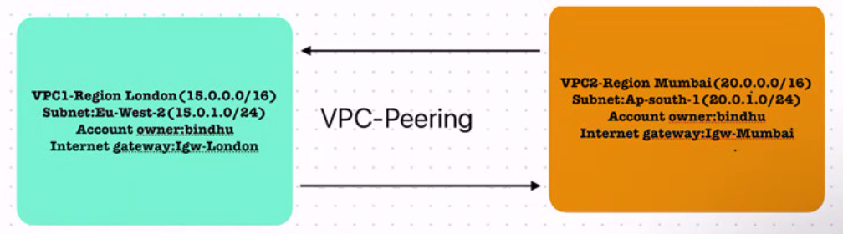

STEP-1**: LONDON-REGION**

Create vpc

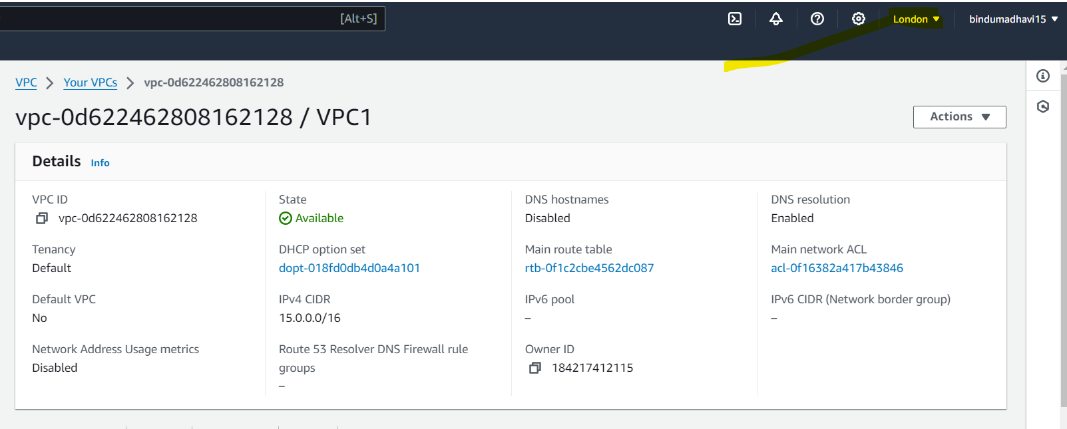

Create subnet:

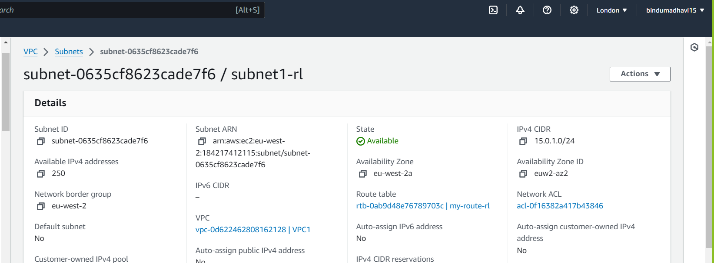

Create internet Gateway: Attach to VPC1

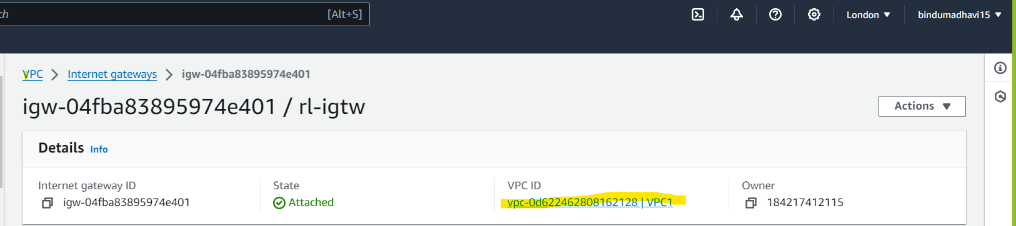

Create Route Table :

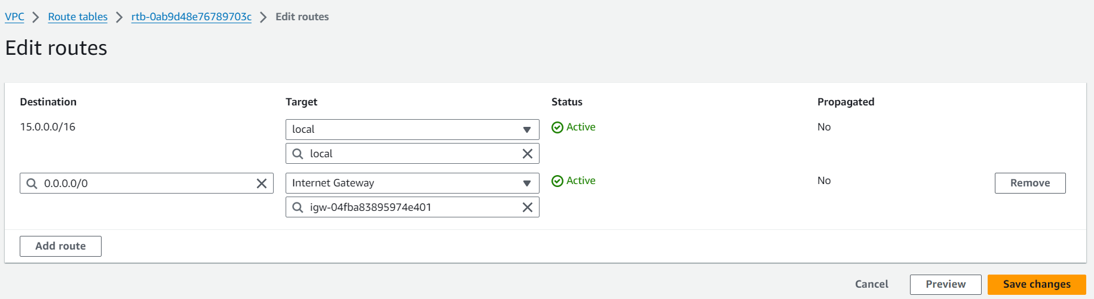

STEP-2:

Follow the same procedure as in step-1.

Create VPC in Mumbai-Region. (20.0.0.0/16)

subnet in ap-south-1 (20.0.1.0/24)

create Internet-gateway and attach it to VPC

create Route-Tables (edit routes, add internet-Gateway and subnet assoications)

STEP-3:

Now create 2 instances one in London and another in Mumbai with in the created subnets

LONDON INSTANCE: 🡪 copy private IP

MUMBAI INSTANCE:🡪 copy private IP

SSH to London instance and check connectivity using ‘ ping Mumbai-instance-private-IP’

Packets will be only transmitted but won’t be received which means no connectivity.

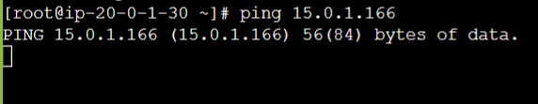

Now,

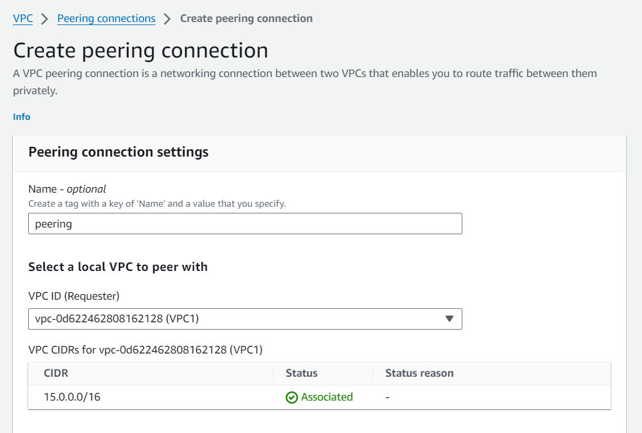

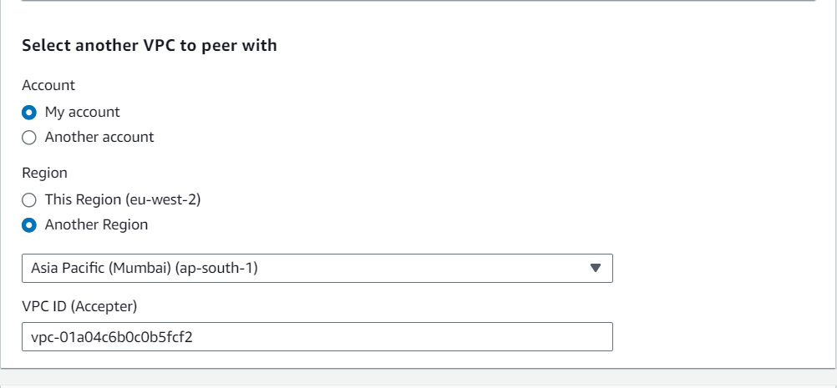

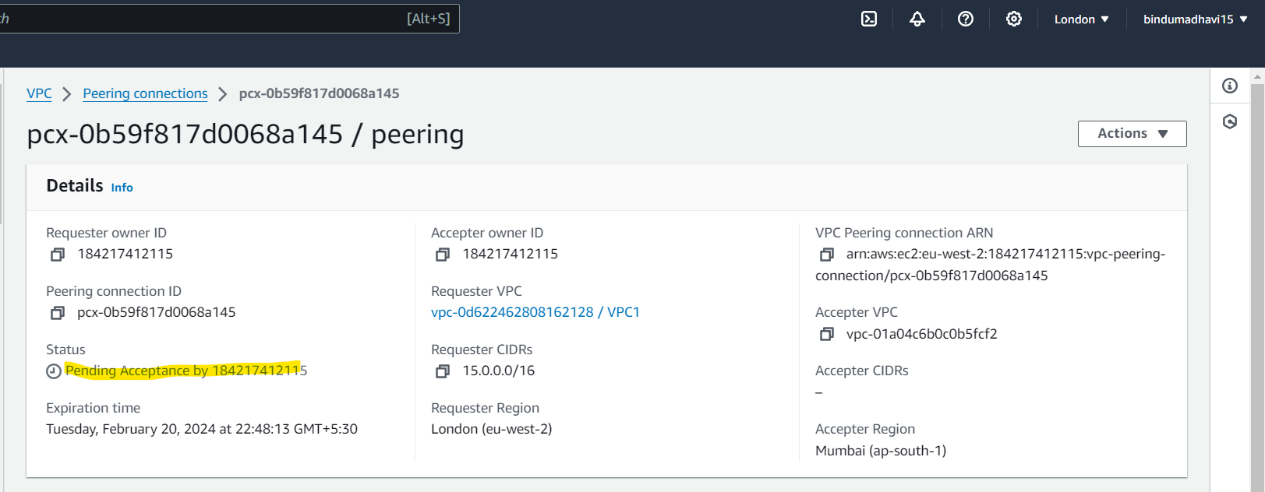

Note:- We need to Accept request in Actions ‘Mumbai-region’ then the peering connectivity will be Active.

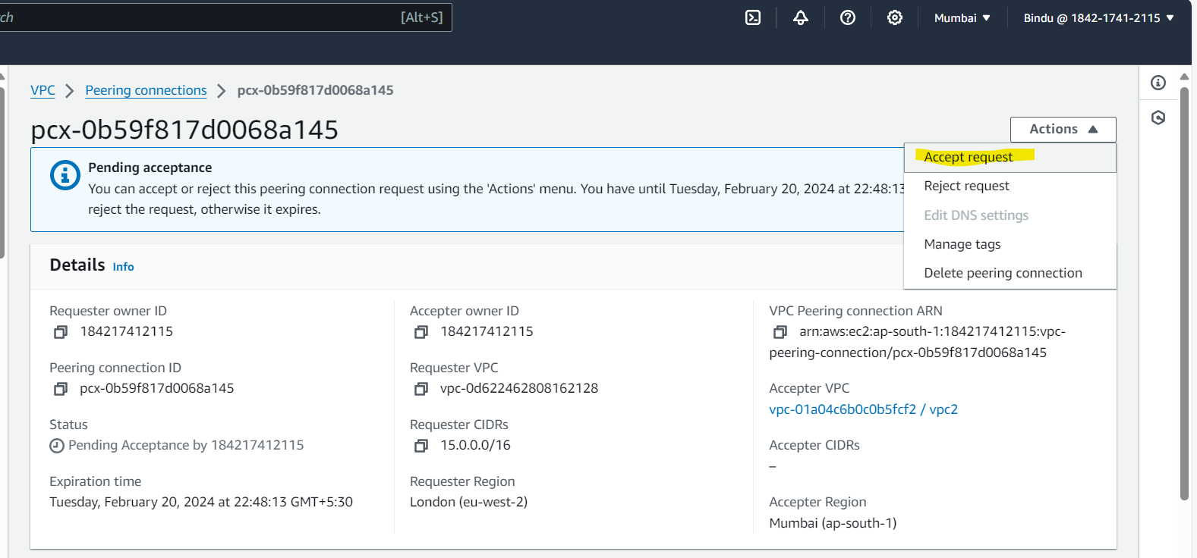

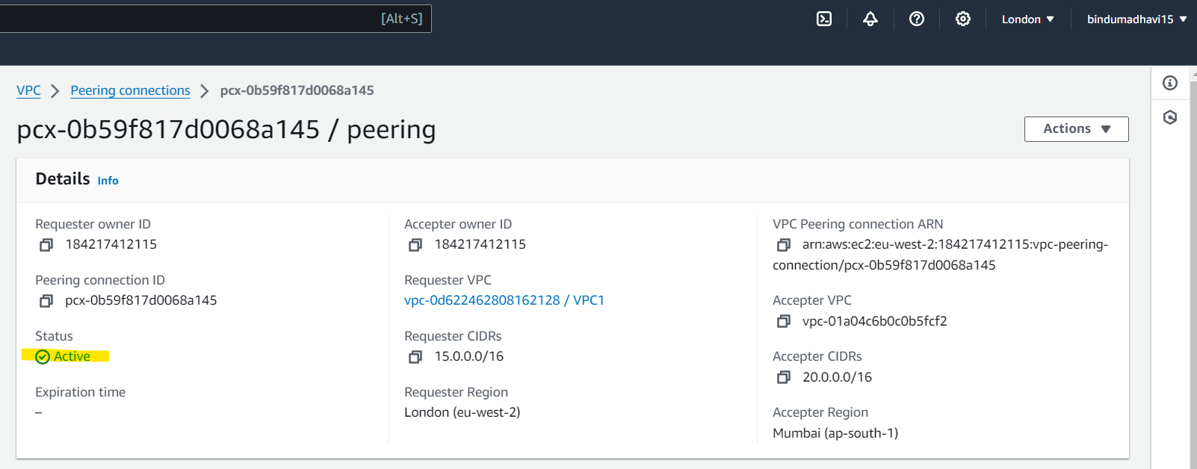

After accepting the request we need to add a entries in route table for both the regions.

Route Table in London

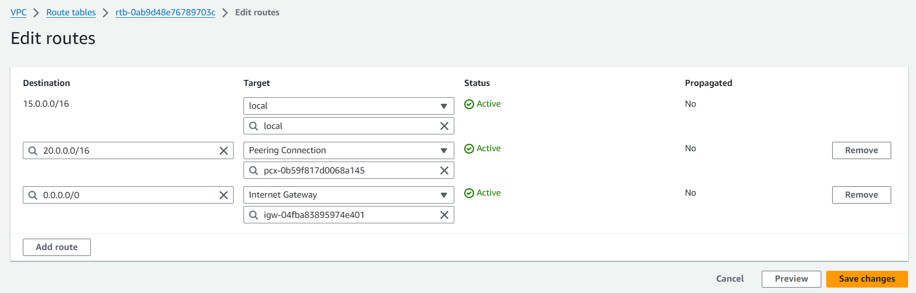

Route Table in Mumbai

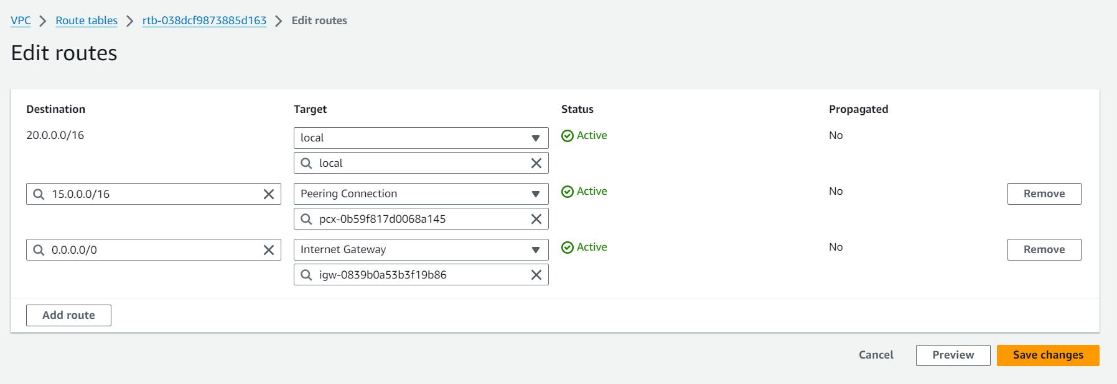

Now, we add security group for the instances in both the regions.

London-region security group

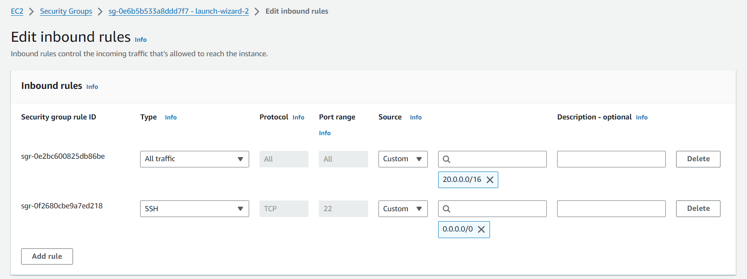

Mumbai-Region security group

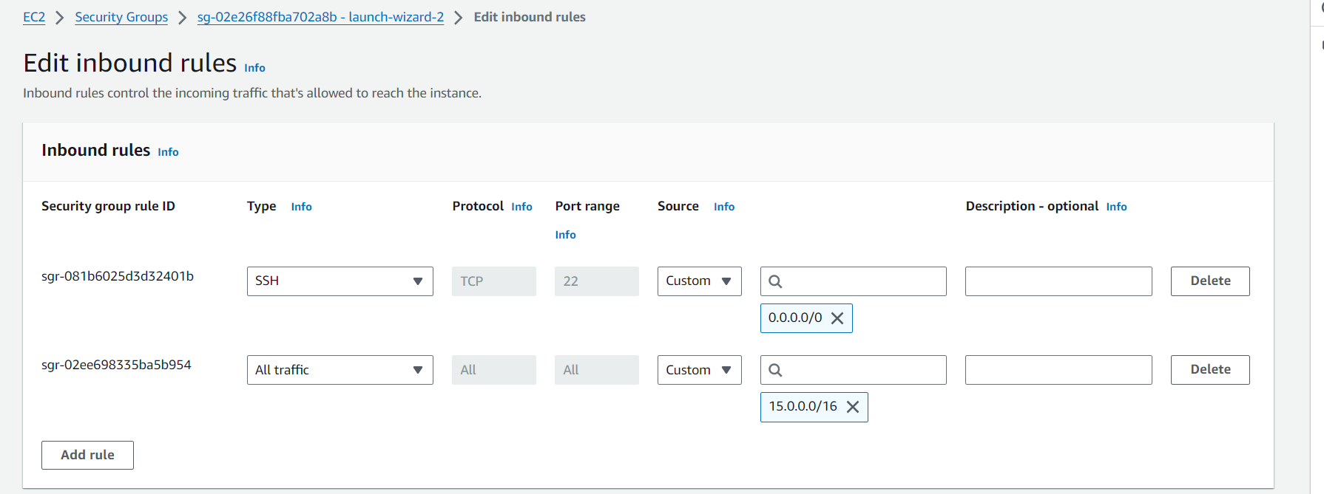

NOW, check the connectivity again

LONDON INSTANCE: 🡪 copy private IP

MUMBAI INSTANCE:🡪 copy private IP

SSH to Mumbai instance and check connectivity using ‘ ping London-instance-private-IP’

Here , Mumbai ip = 20.0.1.30

London ip = 15.0.1.166

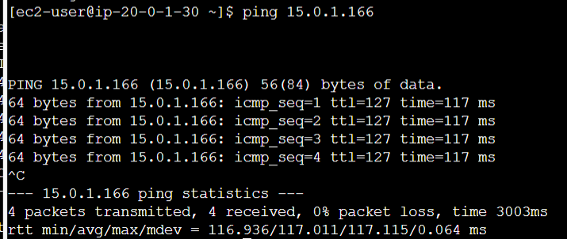

Number of packets transmitted from Mumbai region =4

Number of packets received from london region = 4

Hence, packets transmitted = packets received which proves that connectivity between instances of different regions or two different VPC’s is established using VPC peering.